**Susana E. Deustua**

Susana Deustua <deustua@stsci.edu>

**Titulo**:  The Nancy Grace Roman Space Telescope

**Resumen**:  The Nancy Grace Roman Space Telescope is scheduled to be launched in the mid 2020’s.   It is designed to investigate dark energy and dark matter, search for and characterize exoplanets and study many topics in infrared astrophysics.  Roman Space Telescope 2.4m primary is the same size as Hubble’s, but Roman’s Wide Field Instrument has a field of view that is 100 times larger (approximately 0.3 square degrees), covering the wavelength range between 0.5 to 2 microns with 18 detectors.   The Coronagraph Instrument is a technology demonstrator, that will image and characterize rocky exoplanets.  Roman data will have no proprietary period.   I will describe the mission, the observatory and the science Roman enables.

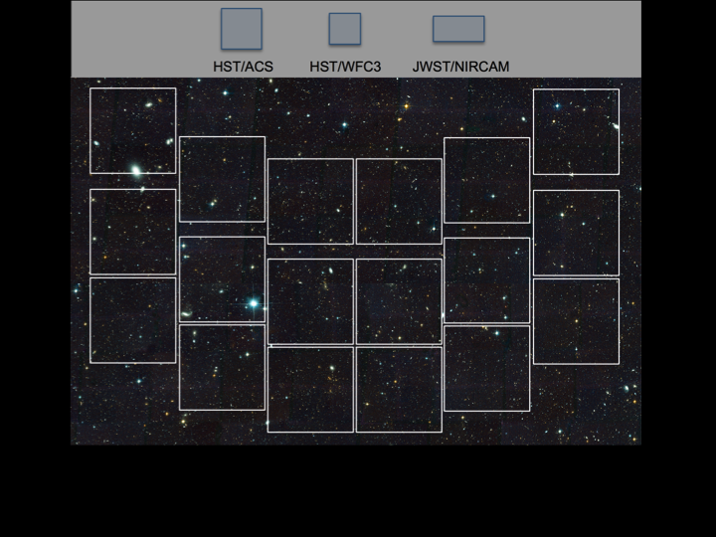

This image shows the field of view of the Wide Field Instrument, and that of HST and JWST for comparison.

More information can be found at:

[https://www.nasa.gov/content/goddard/nancy-grace-roman-space-telescope](https://eur04.safelinks.protection.outlook.com/?url=https%3A%2F%2Fwww.nasa.gov%2Fcontent%2Fgoddard%2Fnancy-grace-roman-space-telescope&data=02%7C01%7Cener.salinas%40hitachi-powergrids.com%7Cee7db82305244f152a0608d83d335591%7C7831e6d9dc6c4cd19ec61dc2b4133195%7C0%7C0%7C637326638010041266&sdata=%2FXcVe8wSSMA8YRo6xTm5FPgmjiNxyB9eigVXre3taFg%3D&reserved=0)

[https://www.stsci.edu/roman](https://eur04.safelinks.protection.outlook.com/?url=https%3A%2F%2Fwww.stsci.edu%2Froman&data=02%7C01%7Cener.salinas%40hitachi-powergrids.com%7Cee7db82305244f152a0608d83d335591%7C7831e6d9dc6c4cd19ec61dc2b4133195%7C0%7C0%7C637326638010041266&sdata=cA%2Fm4Dkk%2BytfFjiHv8DghWiIlGo4TOsLVyoRsEsGjFc%3D&reserved=0)

[https://wfirst.ipac.caltech.edu/](https://eur04.safelinks.protection.outlook.com/?url=https%3A%2F%2Fwfirst.ipac.caltech.edu%2F&data=02%7C01%7Cener.salinas%40hitachi-powergrids.com%7Cee7db82305244f152a0608d83d335591%7C7831e6d9dc6c4cd19ec61dc2b4133195%7C0%7C0%7C637326638010051268&sdata=C67dzQ3Ee3DBZFC645gcOruikDR%2B0g6o6aO7QlpGZ2I%3D&reserved=0)